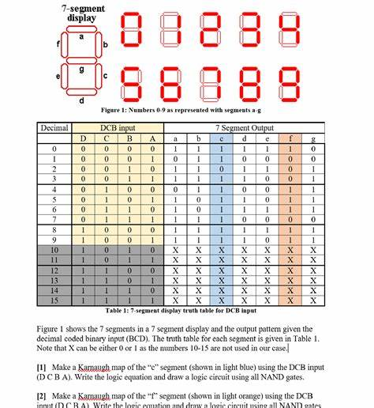

**Using a seven-segment display with an ESP8266**

Components Needed:

1.ESP8266 Module

2.Seven-Segment Display (common cathode or common anode)

3.Resistors (typically 220Ω for each segment)

4.Breadboard and Jumper Wires

**Wiring:**

1. **Identify the Pins**: Check the datasheet for your seven-segment display to know which pins correspond to each segment (A, B, C, D, E, F, G, and common).
2. **Connect Segments**: Connect each segment pin to a GPIO pin on the ESP8266 through a resistor.
3. **Common Pin**: Connect the common cathode or anode to ground or VCC, respectively.

**Example Wiring (Common Cathode):**

* A to GPIO 2 – D4
* B to GPIO 4 – D2
* C to GPIO 5 – D1
* D to GPIO 12 - D6
* E to GPIO 13 – D7
* F to GPIO 14 – D5
* G to GPIO 15 – D8
* Common Cathode to GND

### Code : // Define segment pins

### const int a = 2;

### const int b = 4;

### const int c = 5;

### const int d = 12;

### const int e = 13;

### const int f = 14;

### const int g = 15;

### // Array to represent the numbers

### const int numbers[10][7] = {

### {1, 1, 1, 1, 1, 1, 0}, // 0

### {0, 1, 1, 0, 0, 0, 0}, // 1

### {1, 1, 0, 1, 1, 0, 1}, // 2

### {1, 1, 1, 1, 0, 0, 1}, // 3

### {0, 1, 1, 0, 0, 1, 1}, // 4

### {1, 0, 1, 1, 0, 1, 1}, // 5

### {1, 0, 1, 1, 1, 1, 1}, // 6

### {1, 1, 1, 0, 0, 0, 0}, // 7

### {1, 1, 1, 1, 1, 1, 1}, // 8

### {1, 1, 1, 1, 0, 1, 1} // 9

### };

### void setup() {

### pinMode(a, OUTPUT);

### pinMode(b, OUTPUT);

### pinMode(c, OUTPUT);

### pinMode(d, OUTPUT);

### pinMode(e, OUTPUT);

### pinMode(f, OUTPUT);

### pinMode(g, OUTPUT);

### }

### void loop() {

### for (int num = 0; num < 10; num++) {

### displayNumber(num);

### delay(1000);

### }

### }

### void displayNumber(int num) {

### digitalWrite(a, numbers[num][0]);

### digitalWrite(b, numbers[num][1]);

### digitalWrite(c, numbers[num][2]);

### digitalWrite(d, numbers[num][3]);

### digitalWrite(e, numbers[num][4]);

### digitalWrite(f, numbers[num][5]);

### digitalWrite(g, numbers[num][6]);

### }

### Explanation:

* **Pin Definitions**: Adjust GPIO pins according to your setup.
* **Numbers Array**: Each array element corresponds to a digit and the segments that need to be lit.
* **Loop**: It cycles through numbers 0-9, lighting up the corresponding segments.

### Uploading Code:

1. Connect your ESP8266 to your computer.
2. Select the correct board and port in the Arduino IDE.
3. Upload the code.

### Result:

Once uploaded, the display should cycle through numbers 0 to 9 every second.